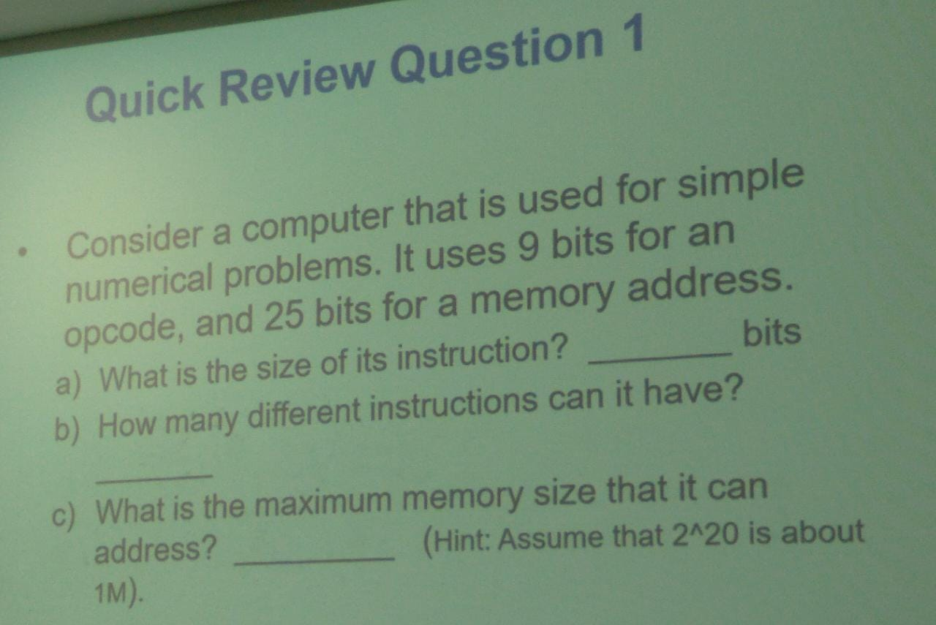

Answers

1. 9 bits+ 25bits = 34 bits
2. 29 = 512
3. 225  = 33,554,432 bytes =32 MB